NaN Value

What is NaN Value
# Source: AI Source: Provided by: [Data Path: Persons Table -> ID Column: 1, Name_En Column: Motasem Essam] -> From: [Chatgpt (GPT‑5 Mini)] on [12/10/2025]
NaN stands for “Not a Number.”
It is a special value used in computing and data analysis to represent a numeric value that is undefined or cannot be represented as a valid number.

When NaN Appears
# Source: AI Source: Provided by: [Data Path: Persons Table -> ID Column: 1, Name_En Column: Motasem Essam] -> From: [Chatgpt (GPT‑5 Mini)] on [12/10/2025]
NaN usually appears when a mathematical operation cannot produce a valid numeric result.
Examples
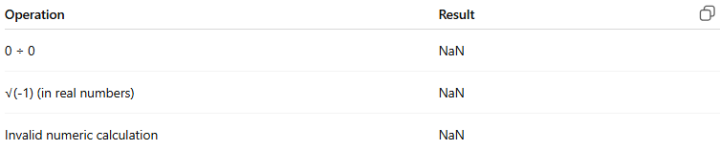
Operation | Result
0 ÷ 0 | NaN
√(-1) (in real numbers) | NaN
Invalid numeric calculation | NaN
Example in programming:
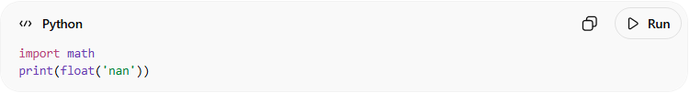
import math
print(float('nan'))
Output:
NaN

NaN in Data Analysis
# Source: AI Source: Provided by: [Data Path: Persons Table -> ID Column: 1, Name_En Column: Motasem Essam] -> From: [Chatgpt (GPT‑5 Mini)] on [12/10/2025]
In datasets, NaN often represents missing or undefined numeric data.
Example dataset:

Name | Score
Ali | 85
Sara | NaN
Omar | 90
Here NaN means the score is missing or undefined.

Difference Between NaN, N/A, and NULL
# Source: AI Source: Provided by: [Data Path: Persons Table -> ID Column: 1, Name_En Column: Motasem Essam] -> From: [Chatgpt (GPT‑5 Mini)] on [12/10/2025]
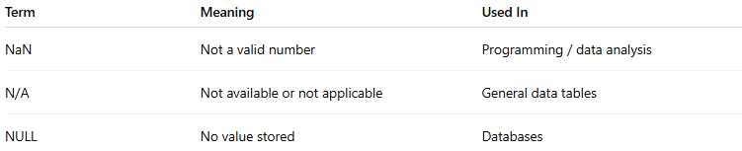
Term | Meaning | Used In
NaN | Not a valid number | Programming / data analysis
N/A | Not available or not applicable | General data tables
NULL | No value stored | Databases

Important Property of NaN
# Source: AI Source: Provided by: [Data Path: Persons Table -> ID Column: 1, Name_En Column: Motasem Essam] -> From: [Chatgpt (GPT‑5 Mini)] on [12/10/2025]
One unique property is:
NaN ≠ NaN
Even when compared with itself, NaN is not equal to NaN.

✅ In simple terms:
# Source: AI Source: Provided by: [Data Path: Persons Table -> ID Column: 1, Name_En Column: Motasem Essam] -> From: [Chatgpt (GPT‑5 Mini)] on [12/10/2025]
NaN is a special value used to represent an invalid or undefined numeric result in computations or datasets.

